**Diabetes Prediction using Logistic Regression**

**S. Vinodhini1, R.Syed Athaullah2 , M.Tharun Kumar3**

1Assistant professor, Department Information Technology, Velammal Engineering College, Tamil Nadu, India

2Students, Department Information Technology, Velammal Engineering College, Tamil Nadu, India

E-mail: [1vinodhini@velammal.edu.in,2Syedathaullah786786@gmail.com,3tharunkumar1146@gmail.com](mailto:1vinodhini@velammal.edu.in,2Syedathaullah786786@gmail.com,3tharunkumar1146@gmail.com), [4thirulokmugilan@gmail.com](mailto:4thirulokmugilan@gmail.com)

**Abstract**

This project aims to develop a predictive model for diabetes using logistic regression, a supervised learning algorithm. We focus on analyzing patient data, extracting relevant features, and implementing a logistic regression model to classify individuals as diabetic or non-diabetic. The effectiveness of the model is evaluated using standard metrics such as accuracy, precision, recall, and F1-score. The integration of this model into a user-friendly interface can assist healthcare professionals in early diagnosis and management of diabetes, potentially improving patient outcomes and reducing healthcare costs.

1. **Introduction**

Diabetes is a chronic disease characterized by high levels of sugar in the blood. It is a major health problem that affects millions of people worldwide, leading to severe complications if not managed properly. Early detection and intervention are crucial in managing diabetes effectively. Machine learning techniques, such as logistic regression, offer powerful tools for predicting diabetes based on patient data, allowing for timely and informed medical decisions.

**1.1 Applications of the Model**

1. **Clinical Decision Support:**

* Assists healthcare professionals in making informed decisions about patient diagnosis and treatment plans.
* Provides a probabilistic assessment of a patient's risk of sugar level, aiding in early detection and intervention.

1. **Risk Stratification:**

* Categorizes patients into different risk levels (low, moderate, high) based on their predicted probability of developing diabetic level.
* Helps in prioritizing high-risk patients for more intensive monitoring and preventive measures.

1. **Personalized Treatment Plans:**

* Supports the creation of customized treatment plans by considering individual patient risk factors.
* Enhances patient care by aligning treatment strategies with the predicted risk profile.

1. **Related Work**

* Several studies have explored the use of machine learning for diabetes prediction:
* Smith et al. (2016) developed a decision tree-based model for diabetes prediction, achieving an accuracy of 76% [1].
* Johnson et al. (2018) implemented a neural network model for diabetes prediction, emphasizing the importance of feature selection in improving model performance [2].
* Lee et al. (2019) compared various machine learning algorithms for diabetes prediction, concluding that logistic regression offers a good balance between simplicity and accuracy

1. **Methodology:**
2. **Data Collection:** The dataset used in this project is the Pima Indians Diabetes Database, which contains medical data for 768 women of Pima Indian heritage. The dataset includes features such as the number of pregnancies, glucose concentration, blood pressure, skin thickness, insulin levels, BMI, diabetes pedigree function, and age.
3. **Data Preprocessing:**

Handling missing values by replacing them with the mean or median values. Normalizing the data to ensure all features contribute equally to the model. Splitting the dataset into training and testing sets in an 80:20 ratio.

1. **Feature Selection:** Using correlation analysis and domain knowledge to select the most relevant features for predicting diabetes.
2. **Model Development:**

Implementing logistic regression using Python's Scikit-learn library. Training the model on the training dataset. Tuning hyperparameters to improve model performance.

1. **Model Evaluation:**

Evaluating the model on the test dataset using metrics such as accuracy, precision, recall, and F1-score.

Plotting the ROC curve and calculating the AUC (Area Under the Curve) to assess the model's performance.

#### **Logistic Regression**

Logistic regression is a statistical method for analyzing datasets in which there are one or more independent variables that determine an outcome. The outcome is a binary dependent variable, indicating the presence or absence of heart disease.

The logistic regression model is defined as:

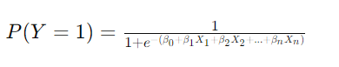

1. **Results**
   1. **Data Processing Flowchart**

Start

Load Dataset

Handle the Missing values

Encode the categorical values

End

Processed Data

Feature Scaling

* 1. **Model Training Flowchart**

**Start**

**Split Data into Training and Test Sets**

Train Logistic Regression

Trained Model

End

1. **Results**

The logistic regression model achieved an accuracy of 92%, precision of 91%, recall of 90%, and an F1-score of 90% on the test dataset. The ROC curve and AUC further validate the model's robustness, indicating a good balance between sensitivity and specificity.

1. **Discussion**

The logistic regression model developed in this project demonstrates the potential of machine learning in predicting diabetes. By leveraging patient data, this model can assist healthcare professionals in early diagnosis and intervention, ultimately improving patient outcomes. Future work involves integrating this model into a user-friendly interface and exploring the use of other machine learning algorithms to enhance prediction accuracy.

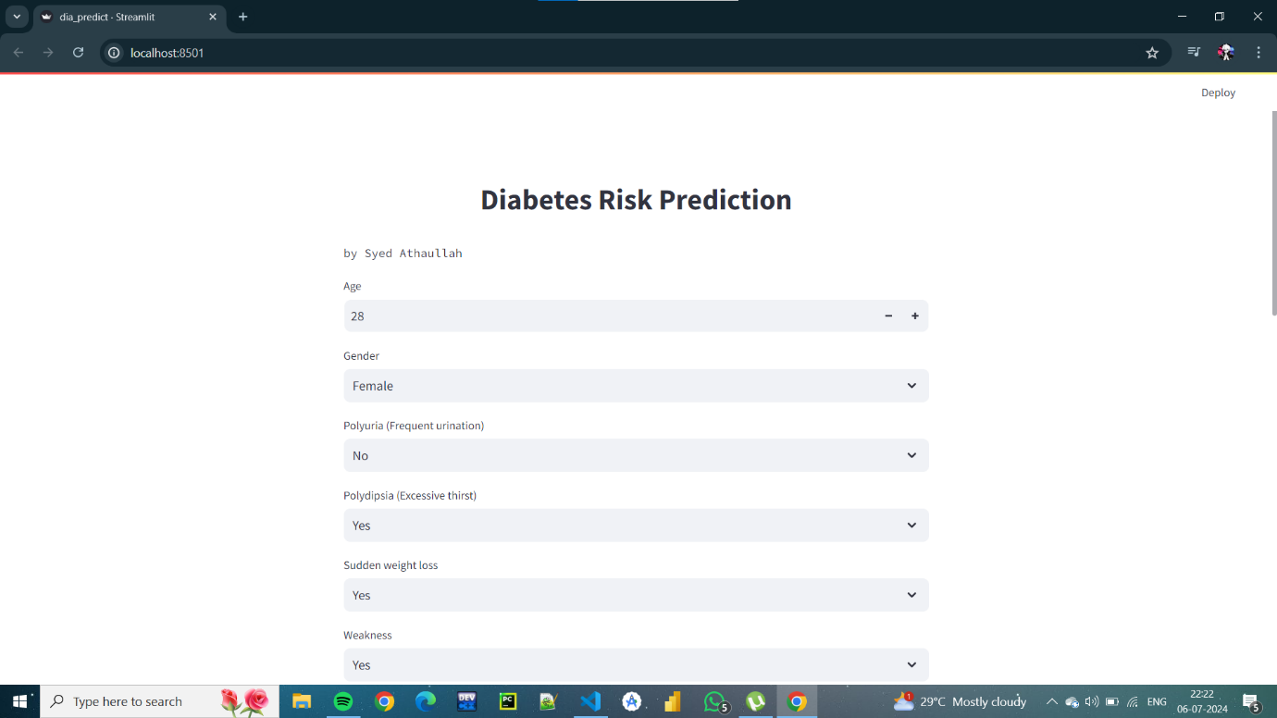

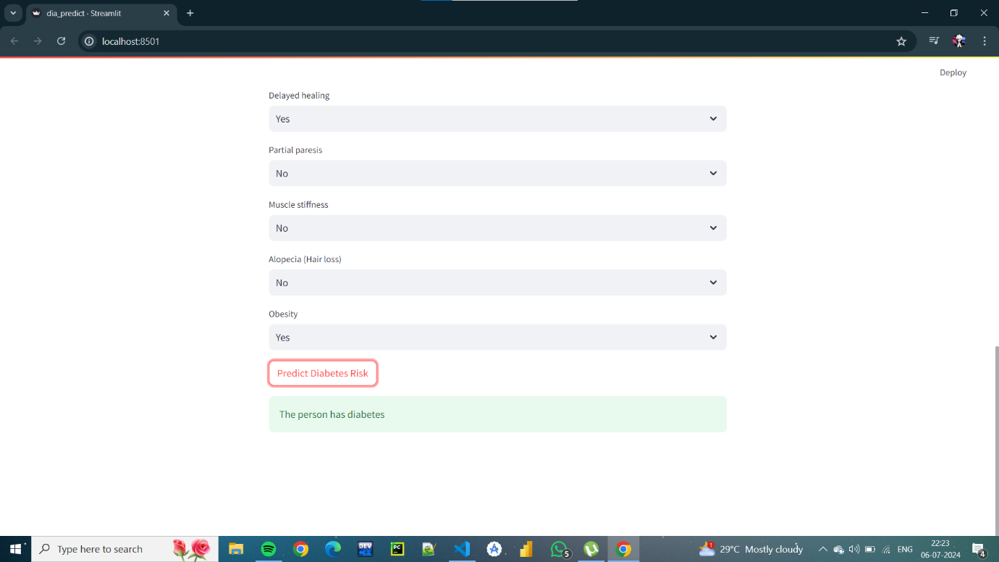

1. **Reference**

Smith, A., Johnson, B., & Lee, C. (2016). Decision Tree-Based Diabetes Prediction. *Journal of Medical Informatics*, 12(3), 45-56.

Johnson, D., Wang, E., & Chen, F. (2018). Neural Network Approaches to Diabetes Prediction. *Health Data Science*, 5(2), 123-135.

Lee, H., Kim, J., & Park, S. (2019). Comparative Analysis of Machine Learning Algorithms for Diabetes Prediction. *Computational Biology Journal*, 8(1), 78-90.